# Informações do estudo

Referência: Thangarasu - Strain Gauge

Grandeza: Força

Tipo: Fr

Material: Mild steel

Ferramenta: TiCN coated cemented carbide

Número de experimentos: 27

Observações:  
Strain Gauge Dynamometer

# Unidades

Velocidade: rpm

Avanço: mm/rev

Profundidade de corte: mm

Força: N

# Dados de teste

|  |  |  |  |
| --- | --- | --- | --- |
| Força | n | f | a |
| 380.85 | 90.0 | 0.2 | 0.6 |
| 637.77 | 270.0 | 0.6 | 0.2 |
| 523.23 | 180.0 | 0.4 | 0.6 |
| 551.44 | 180.0 | 0.6 | 0.6 |
| 410.01 | 90.0 | 0.4 | 0.6 |
| 492.76 | 180.0 | 0.2 | 0.6 |

# Dados de treino

|  |  |  |  |
| --- | --- | --- | --- |
| Força | n | f | a |
| 624.98 | 270.0 | 0.4 | 0.6 |
| 513.64 | 180.0 | 0.4 | 0.4 |
| 589.43 | 270.0 | 0.2 | 0.4 |
| 598.09 | 270.0 | 0.2 | 0.6 |
| 541.85 | 180.0 | 0.6 | 0.4 |
| 372.39 | 90.0 | 0.2 | 0.4 |
| 478.47 | 180.0 | 0.2 | 0.4 |
| 656.01 | 270.0 | 0.6 | 0.6 |
| 646.8 | 270.0 | 0.6 | 0.4 |
| 444.24 | 90.0 | 0.6 | 0.6 |
| 423.92 | 90.0 | 0.6 | 0.2 |
| 400.6 | 90.0 | 0.4 | 0.4 |
| 583.23 | 270.0 | 0.2 | 0.2 |
| 472.26 | 180.0 | 0.2 | 0.2 |
| 433.14 | 90.0 | 0.6 | 0.4 |
| 616.33 | 270.0 | 0.4 | 0.4 |
| 393.08 | 90.0 | 0.4 | 0.2 |
| 366.75 | 90.0 | 0.2 | 0.2 |
| 608.62 | 270.0 | 0.4 | 0.2 |
| 534.14 | 180.0 | 0.6 | 0.2 |
| 505.93 | 180.0 | 0.4 | 0.2 |

# RN

Número de neurônios: 58

Taxa de aprendizado: 1.000000e-02

Número de épocas: 382

2° camada: True

Função de ativação: tanh

# Erros

**Dados de teste**

* Erro relativo médio: 0.85
* Coeficiente de correlação: 1.0
* Coeficiente de determinação: 1.0
* MSE: 18.22
* RMSE: 4.27

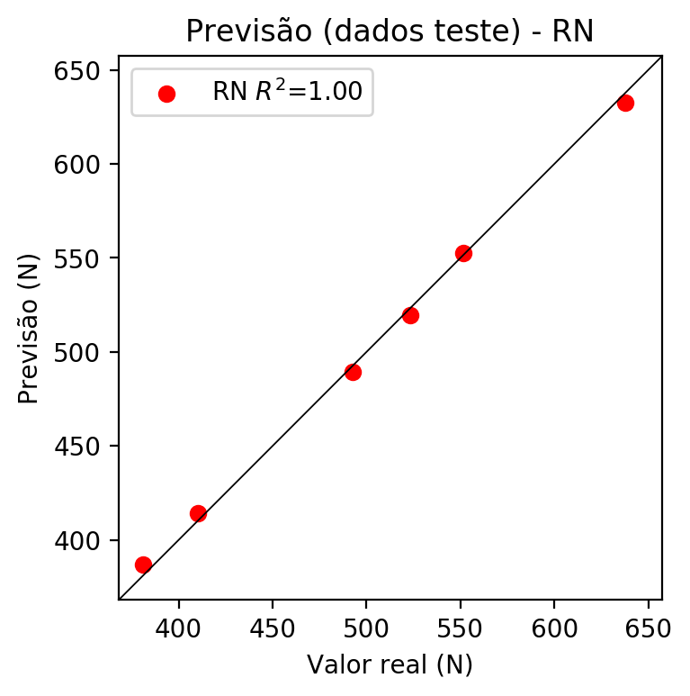

**Dados de treino**

* Erro relativo médio: 0.16
* Coeficiente de correlação: 1.0
* Coeficiente de determinação: 1.0
* MSE: 0.84
* RMSE: 0.92

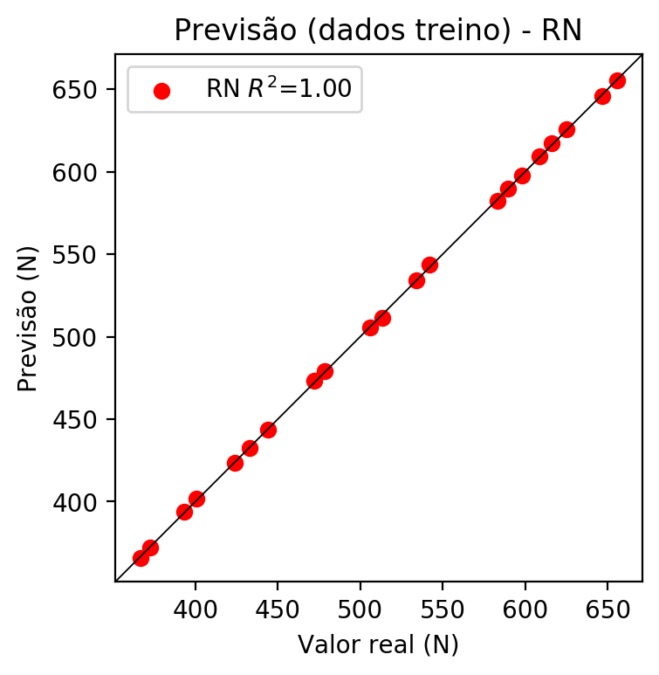

# Pesos

Pesos - camada oculta 1

[[ 0.22527264 0.12179714 -0.20276125 0.04118932 0.14026192 -0.15565  
 -0.04773282 0.024542 -0.02772487 0.04592948 -0.23544818 0.15603958  
 0.0189515 -0.04399054 -0.00458617 -0.08621468 0.00273063 -0.03146315  
 -0.22106756 0.19479708 0.2695347 0.2094252 -0.11403634 0.17895295  
 -0.03038983 -0.22400701 0.24175994 -0.02158858 0.25613722 -0.23501354  
 0.04635721 -0.24492401 -0.19811305 -0.17670514 0.08885757 -0.22342773  
 0.04352297 0.07285016 -0.22972474 -0.1303055 0.13792263 0.12412838  
 0.27825496 0.25575256 0.04580878 0.04706059 -0.01496157 -0.21087211  
 0.27777088 0.26595643 0.10332354 0.09975911 -0.01950792 -0.02404871  
 -0.13780317 0.02091678 -0.00670193 -0.01341821]  
 [-0.23989245 -0.2733231 0.24273907 -0.2365104 -0.316122 0.08329798  
 0.24565516 -0.36315927 -0.01298376 0.0311004 -0.19752763 -0.22124252  
 -0.1596421 -0.00054857 0.1150974 -0.1474327 0.09162255 -0.17222872  
 0.16078 0.19203955 0.05982317 -0.07674073 0.20836005 -0.39235118  
 -0.22558008 -0.056112 -0.23004504 0.14606413 0.0145123 -0.22965373  
 -0.26834622 0.3312406 -0.14467134 -0.17097221 -0.25940695 0.05861285  
 -0.13696347 -0.3148655 -0.27954307 0.05771051 0.0390518 -0.2504708  
 0.14959957 -0.16460115 0.18709221 -0.10171423 -0.2940442 -0.25292584  
 -0.0297378 -0.20470867 -0.01065839 0.11485577 -0.07338274 -0.14529982  
 0.28515756 0.2611166 0.00983186 0.28680527]  
 [ 0.02760341 -0.06520112 -0.13497674 -0.18284355 0.11130978 -0.17679167  
 0.01225313 -0.14254187 0.23088121 0.08860569 0.22564943 -0.06019897  
 -0.11122946 -0.13046238 0.08753623 0.03870475 0.10368653 0.06613065  
 0.1960255 0.3118154 -0.106705 0.14555025 -0.15573396 0.17622548  
 -0.12669757 -0.24482979 0.06590668 -0.04990426 -0.02153246 -0.07838792  
 0.15314908 0.10767077 0.21639673 0.01602186 0.23349364 -0.21402232  
 0.03145858 -0.0298828 -0.16232552 -0.2247618 0.1889821 0.1923918  
 0.09870569 0.00503151 -0.1299157 0.18364672 -0.19986723 -0.01723197  
 -0.1901925 -0.25744355 0.2766174 -0.08735716 -0.25851518 -0.21937141  
 -0.02845602 0.19230115 -0.26606607 0.24556758]]

Bias - camada oculta

[ 0.00172378 0.0078747 0.0009449 0.00195593 -0.05737168 0.01090364  
 -0.02652395 0.00100564 0.02665569 -0.0380844 0.04189916 -0.02609302  
 -0.09389732 0.03840625 0.12915066 -0.02083434 0.00481373 0.01882615  
 0.05882007 -0.09972599 -0.00977989 -0.02354584 0.05583529 -0.01653318  
 0.02923785 0.00420241 0.02212468 -0.01025919 0.01240506 -0.00324155  
 0.04793328 0.09546833 0.008427 0.06887436 0.04817461 0.00643556  
 0.03112548 -0.01326693 -0.01479514 -0.02511511 -0.00927277 -0.00083826  
 0.01967488 -0.04966956 -0.06905546 0.01174278 0.01090434 -0.00358251  
 -0.01645867 -0.01907347 -0.12950516 -0.0162731 -0.00198902 0.13042699  
 -0.05098679 -0.03665355 0.02296683 -0.04104384]

Pesos - camada oculta 2

[[ 0.147762 0.04746227 -0.0842728 ... 0.05690392 0.01722661  
 0.00946137]  
 [-0.2232978 -0.17026858 0.2876569 ... 0.19787365 0.07087874  
 0.22431156]  
 [ 0.01027288 -0.08169715 -0.12858482 ... 0.12745225 -0.20210078  
 0.16567387]  
 ...  
 [-0.11889862 -0.08769498 -0.16821058 ... -0.12562396 -0.16937944  
 0.20119873]  
 [ 0.18560088 0.22669499 0.05244709 ... -0.06816724 0.11722393  
 0.12503475]  
 [ 0.17760427 0.12691723 -0.01518147 ... 0.12604666 0.08549099  
 -0.07996116]]

Bias - camada oculta 2

[ 4.5866007e-03 1.8781362e-02 -1.8208839e-02 -1.6109303e-02  
 -3.0815012e-03 -1.0076416e-02 -7.1420646e-03 -3.1395882e-02  
 -2.9680869e-03 5.3619822e-03 -1.2212910e-02 1.9322727e-02  
 6.7573939e-03 4.8348033e-03 -8.9404089e-03 -8.1068501e-03  
 1.9601502e-02 -5.8309152e-03 -1.1584429e-02 -4.1609895e-03  
 6.2679482e-04 5.6136269e-03 2.5387028e-02 9.3498966e-03  
 -9.0859868e-03 3.5123192e-02 1.2145699e-02 -5.5515640e-03  
 5.3236792e-03 -4.1448344e-02 -5.9209738e-02 9.8793732e-04  
 -2.0399949e-02 -1.6963813e-02 -3.1436794e-05 -1.7357161e-02  
 6.8486128e-03 6.0400129e-03 -7.6890639e-03 -7.5692413e-03  
 -4.5418944e-03 8.6499881e-03 2.8985966e-02 2.1219354e-02  
 -1.0734921e-02 -1.8264189e-02 8.2572080e-02 -4.3805582e-03  
 4.7915954e-02 4.3970430e-03 2.7923457e-02 2.8502639e-02  
 5.2055656e-03 -1.4611939e-02 -2.6082430e-02 2.5185004e-02  
 -6.2588137e-03 1.5552094e-02]

Pesos - camada saída

[[ 0.06647976 0.05412316 -0.14328428 -0.00434927 0.13463753 -0.08333546  
 0.00289563 0.02502662 -0.07245351 -0.01206343 -0.27618715 0.18271154  
 0.00900973 -0.01456568 -0.13698417 -0.08695943 0.06103272 -0.01097407  
 -0.15163574 0.17084111 0.16151056 0.14317551 -0.03627268 0.1556139  
 -0.06200323 -0.17437804 0.23843089 -0.00958397 0.10481971 -0.23010004  
 0.02914997 -0.21830003 -0.17358558 -0.23201191 -0.00165687 -0.1762186  
 0.00976088 0.04514765 -0.16007234 -0.06208034 0.0803305 0.11318149  
 0.24667194 0.23820852 0.04352774 0.01051337 -0.02173778 -0.13786973  
 0.26779762 0.19602245 0.15753467 0.17954583 0.06269217 0.00636662  
 -0.12516345 -0.01997391 0.02691368 -0.01302917]]

# Iterações

|  |  |  |  |  |  |  |
| --- | --- | --- | --- | --- | --- | --- |
| Média | Desvio | n | ln | 2° camada | Função | Épocas |
| -0.0088 | 0.0037 | 10 | 0.1 | False | relu | 38 |
| -0.0081 | 0.0102 | 17 | 0.1 | True | relu | 716 |
| -0.0071 | 0.0067 | 7 | 0.01 | True | tanh | 130 |
| -0.0058 | 0.0024 | 19 | 0.001 | False | tanh | 282 |
| -0.0078 | 0.0069 | 29 | 0.001 | False | relu | 469 |
| -0.0049 | 0.0034 | 88 | 0.1 | False | tanh | 926 |
| -0.0158 | 0.0248 | 95 | 0.0001 | True | relu | 984 |
| -0.0162 | 0.0164 | 10 | 0.01 | True | tanh | 865 |
| -0.5682 | 0.3071 | 58 | 0.001 | True | relu | 8 |
| -0.0066 | 0.0051 | 9 | 0.01 | False | tanh | 514 |
| -0.0171 | 0.0195 | 73 | 0.0001 | True | relu | 729 |
| -0.0493 | 0.0361 | 22 | 0.001 | True | relu | 543 |
| -0.0022 | 0.0018 | 25 | 0.1 | True | relu | 562 |
| -0.008 | 0.0062 | 53 | 0.001 | False | relu | 498 |
| -0.0049 | 0.0018 | 83 | 0.01 | True | relu | 337 |
| -0.1156 | 0.0533 | 99 | 0.01 | False | tanh | 16 |
| -0.0037 | 0.003 | 23 | 0.01 | False | relu | 472 |
| -0.0277 | 0.0142 | 24 | 0.001 | True | relu | 778 |
| -0.0022 | 0.0017 | 58 | 0.01 | True | tanh | 382 |
| -0.0051 | 0.0029 | 35 | 0.1 | False | tanh | 596 |

# RL

# Coeficientes

[0. 0.96114612 0.26709118 0.07161786]

# Erros

**Dados de teste**

* Erro relativo médio: 0.49
* Coeficiente de correlação: 1.0
* Coeficiente de determinação: 1.0
* MSE: 8.12
* RMSE: 2.85

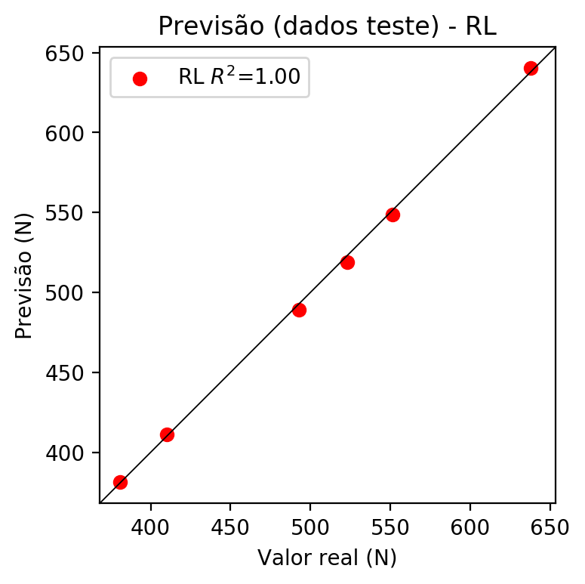

**Dados de treino**

* Erro relativo médio: 0.34
* Coeficiente de correlação: 1.0
* Coeficiente de determinação: 1.0
* MSE: 3.6
* RMSE: 1.9

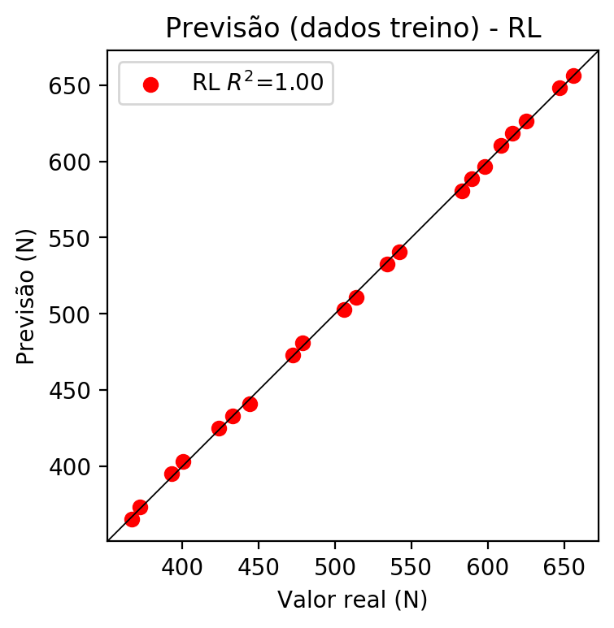

# RP2

# Coeficientes

[ 0. 0.96021219 0.26703401 0.07576388 -0.0117121 -0.00569836  
 -0.00381869 0.00522122 0.0038938 0.00908644]

# Erros

**Dados de teste**

* Erro relativo médio: 0.31
* Coeficiente de correlação: 1.0
* Coeficiente de determinação: 1.0
* MSE: 2.96
* RMSE: 1.72

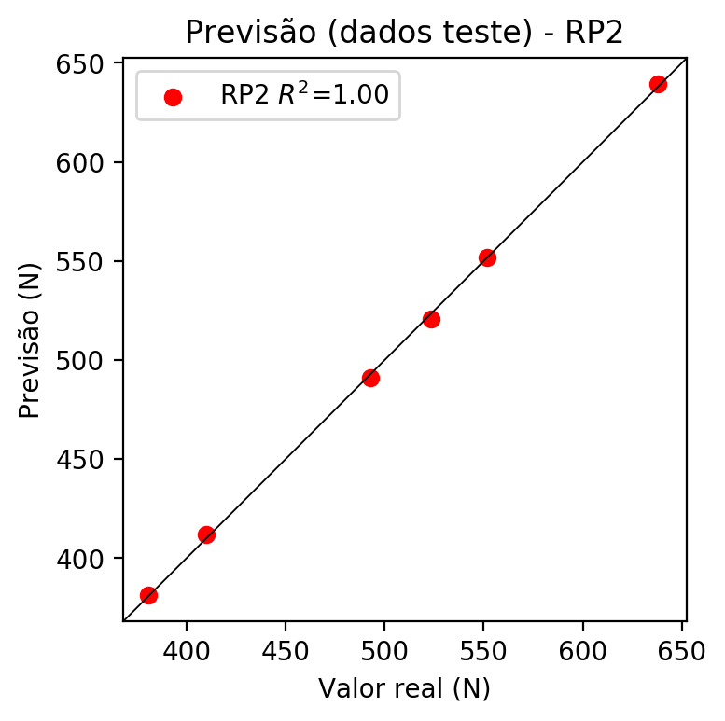

**Dados de treino**

* Erro relativo médio: 0.24
* Coeficiente de correlação: 1.0
* Coeficiente de determinação: 1.0
* MSE: 2.19
* RMSE: 1.48

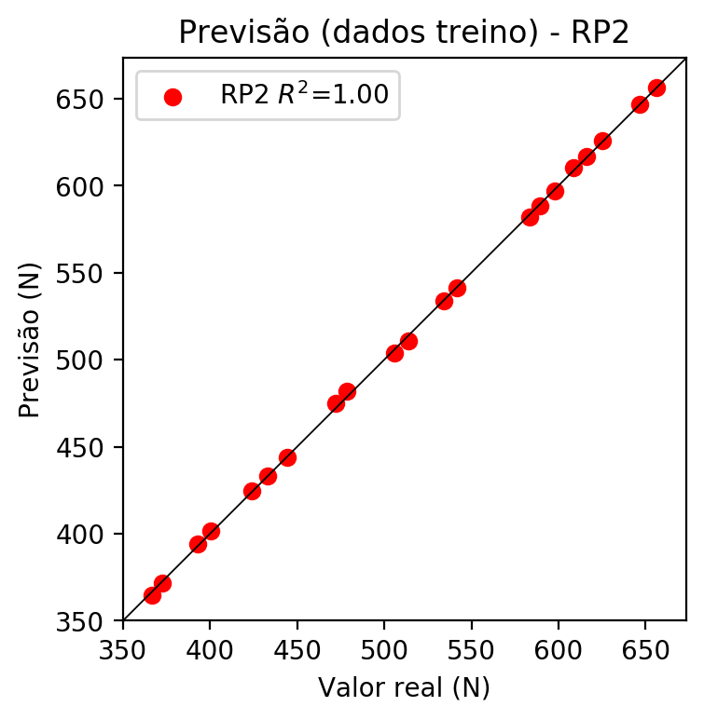

# RP3

# Coeficientes

[ 0. 0.31265011 0.09342005 0.02223837 -0.01143168 -0.00627937  
 -0.00376407 0.00500112 0.00656948 0.0088916 0.45160572 -0.01886331  
 0.00595243 -0.00284204 0.00458498 -0.00753853 0.13494007 0.00669121  
 -0.00651485 0.03212209]

# Erros

**Dados de teste**

* Erro relativo médio: 0.73
* Coeficiente de correlação: 1.0
* Coeficiente de determinação: 1.0
* MSE: 12.63
* RMSE: 3.55

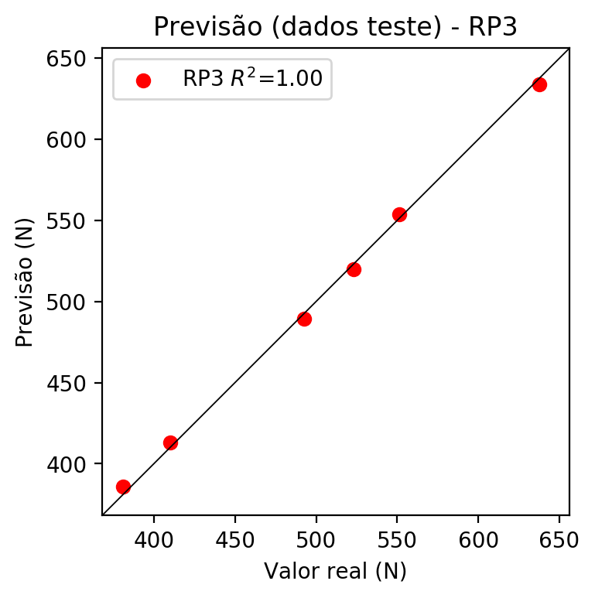

**Dados de treino**

* Erro relativo médio: 0.17
* Coeficiente de correlação: 1.0
* Coeficiente de determinação: 1.0
* MSE: 1.13
* RMSE: 1.06

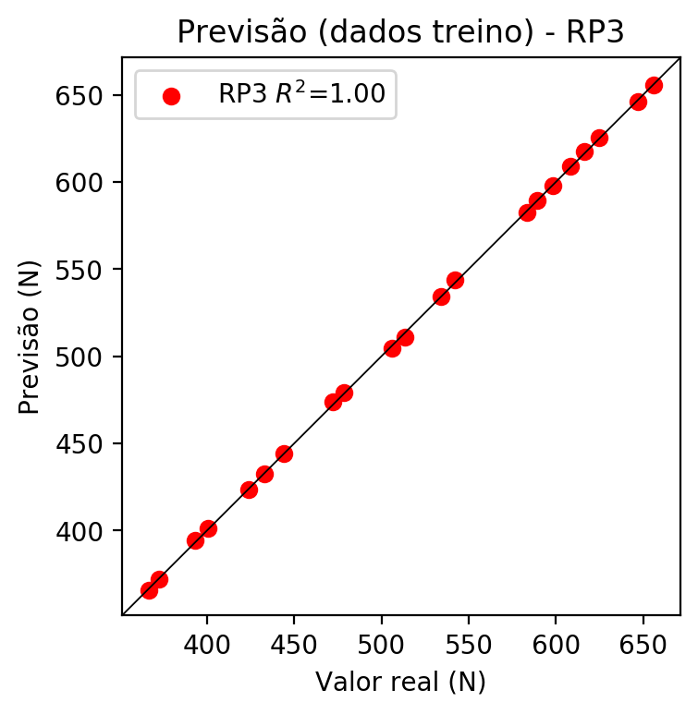

# RP4

# Coeficientes

[ 0.05053889 0.29872664 0.0160324 -0.0207816 0.17316209 -0.02239563  
 0.02300451 -0.00954378 -0.01201429 0.01503076 0.46013355 -0.01335558  
 0.0400431 -0.0011748 -0.02089353 0.01710636 0.18484433 0.00060286  
 0.01620981 0.00722848 -0.14650518 -0.00366212 -0.01212305 0.02806424  
 0.00100321 0.03380662 0.01481953 -0.00339549 -0.01303721 0.01091894  
 -0.01129627 0.01771807 0.00436012 0.0079454 -0.05602788]

# Erros

**Dados de teste**

* Erro relativo médio: 3.5
* Coeficiente de correlação: 1.0
* Coeficiente de determinação: 0.99
* MSE: 337.33
* RMSE: 18.37

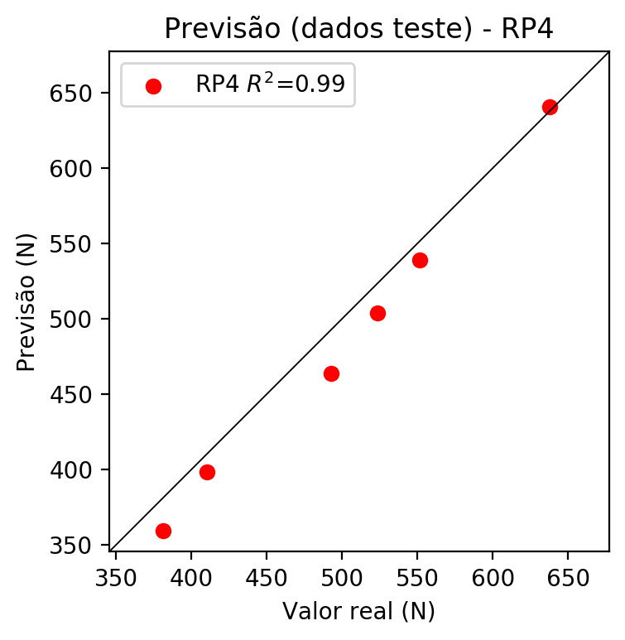

**Dados de treino**

* Erro relativo médio: 0.0
* Coeficiente de correlação: 1.0
* Coeficiente de determinação: 1.0
* MSE: 0.0
* RMSE: 0.0

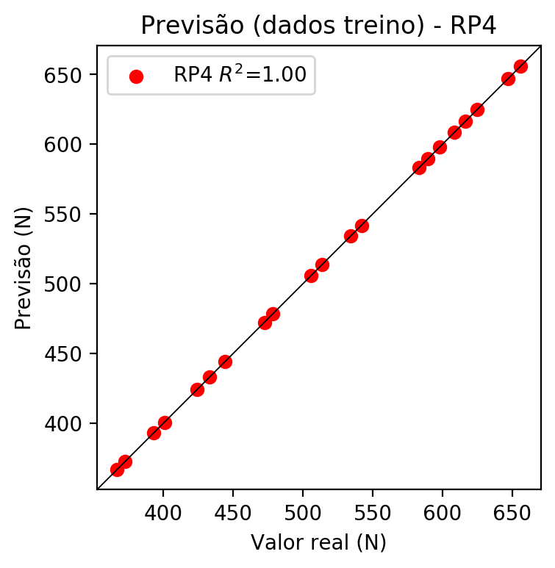

# Geral

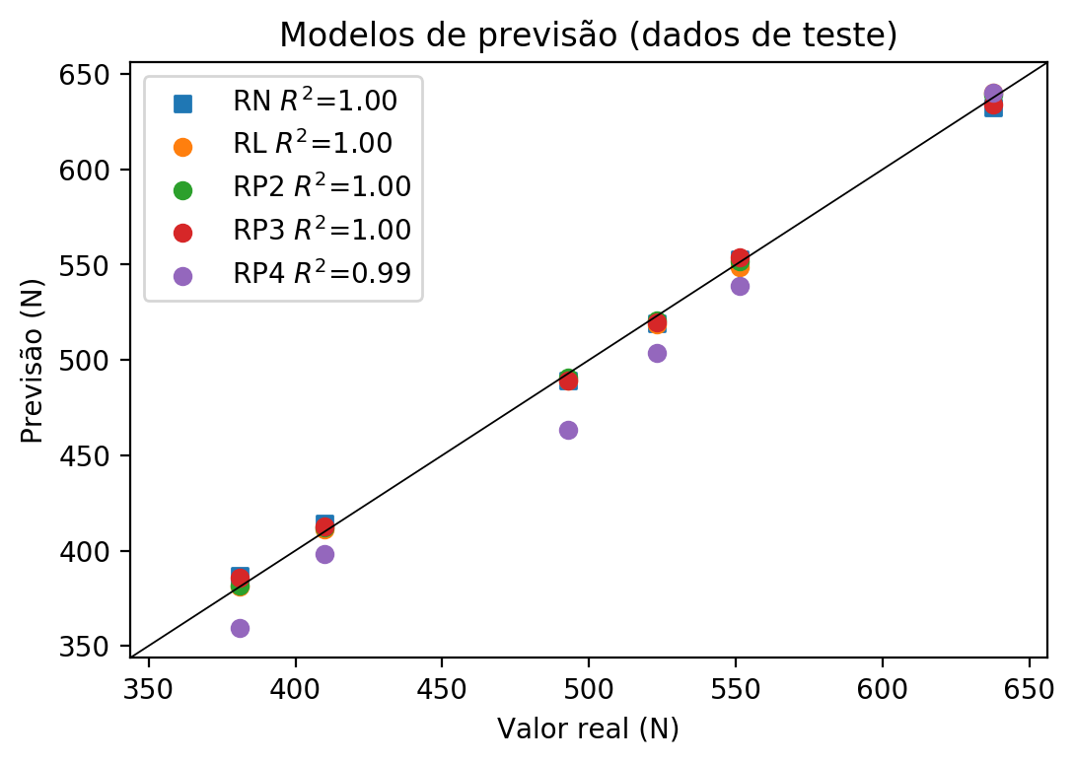

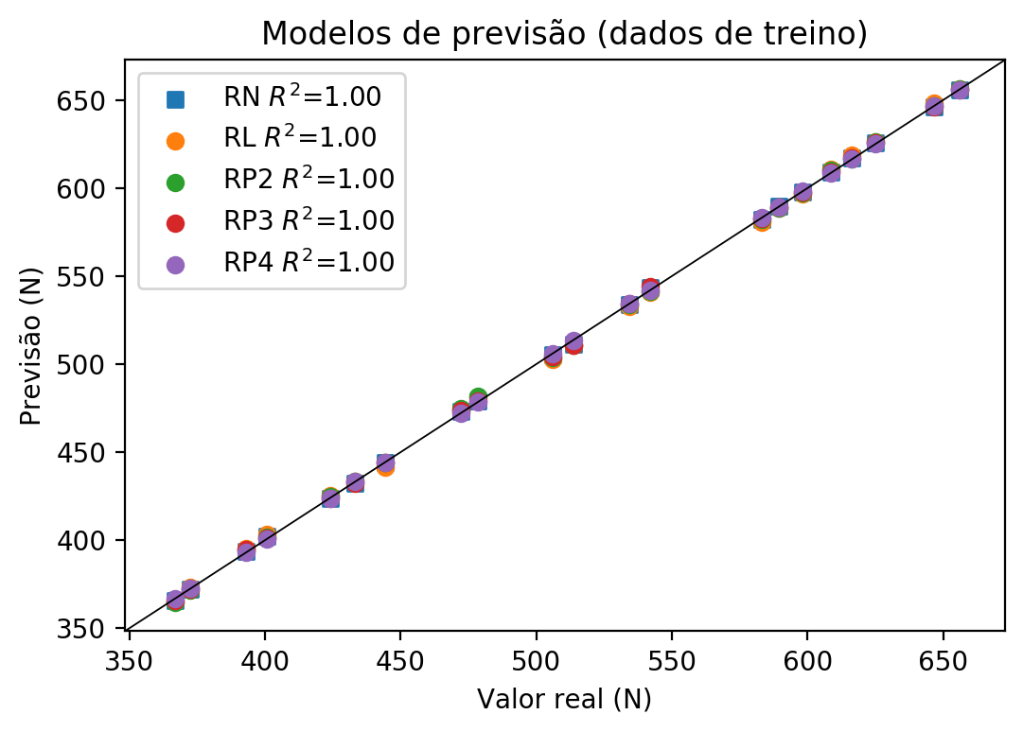

**Dados de teste**

|  |  |  |  |  |  |  |  |  |  |  |
| --- | --- | --- | --- | --- | --- | --- | --- | --- | --- | --- |
| Valor real | RN Previsto | RN Erro (%) | RL Previsto | RL Erro (%) | RP2 Previsto | RP2 Erro (%) | RP3 Previsto | RP3 Erro (%) | RP4 Previsto | RP4 Erro (%) |
| 380.85 | 386.97 | 1.61 | 381.37 | 0.14 | 381.52 | 0.18 | 385.91 | 1.33 | 359.29 | 5.66 |
| 637.77 | 632.6 | 0.81 | 640.38 | 0.41 | 639.38 | 0.25 | 634.05 | 0.58 | 640.4 | 0.41 |
| 523.23 | 519.41 | 0.73 | 518.89 | 0.83 | 520.58 | 0.51 | 519.75 | 0.67 | 503.61 | 3.75 |
| 551.44 | 552.76 | 0.24 | 548.8 | 0.48 | 551.71 | 0.05 | 553.62 | 0.4 | 538.76 | 2.3 |
| 410.01 | 414.18 | 1.02 | 411.28 | 0.31 | 412.01 | 0.49 | 412.86 | 0.7 | 397.99 | 2.93 |
| 492.76 | 489.38 | 0.69 | 488.99 | 0.77 | 490.86 | 0.39 | 489.39 | 0.68 | 463.4 | 5.96 |

**Dados de treino**

|  |  |  |  |  |  |  |  |  |  |  |
| --- | --- | --- | --- | --- | --- | --- | --- | --- | --- | --- |
| Valor real | RN Previsto | RN Erro (%) | RL Previsto | RL Erro (%) | RP2 Previsto | RP2 Erro (%) | RP3 Previsto | RP3 Erro (%) | RP4 Previsto | RP4 Erro (%) |
| 624.98 | 625.62 | 0.1 | 626.51 | 0.24 | 626.0 | 0.16 | 625.5 | 0.08 | 624.98 | 0.0 |
| 513.64 | 511.47 | 0.42 | 510.87 | 0.54 | 510.88 | 0.54 | 510.87 | 0.54 | 513.64 | 0.0 |
| 589.43 | 589.7 | 0.05 | 588.59 | 0.14 | 588.38 | 0.18 | 589.2 | 0.04 | 589.43 | 0.0 |
| 598.09 | 597.62 | 0.08 | 596.6 | 0.25 | 597.05 | 0.17 | 597.83 | 0.04 | 598.09 | 0.0 |
| 541.85 | 543.73 | 0.35 | 540.78 | 0.2 | 541.48 | 0.07 | 543.83 | 0.37 | 541.85 | 0.0 |
| 372.39 | 372.08 | 0.08 | 373.35 | 0.26 | 371.83 | 0.15 | 372.34 | 0.01 | 372.39 | 0.0 |
| 478.47 | 479.15 | 0.14 | 480.97 | 0.52 | 481.68 | 0.67 | 479.26 | 0.17 | 478.47 | 0.0 |
| 656.01 | 655.57 | 0.07 | 656.42 | 0.06 | 656.36 | 0.05 | 655.75 | 0.04 | 656.01 | 0.0 |
| 646.8 | 646.08 | 0.11 | 648.4 | 0.25 | 646.65 | 0.02 | 645.98 | 0.13 | 646.8 | 0.0 |
| 444.24 | 443.9 | 0.08 | 441.18 | 0.69 | 443.9 | 0.08 | 444.24 | 0.0 | 444.24 | 0.0 |
| 423.92 | 423.61 | 0.07 | 425.14 | 0.29 | 424.86 | 0.22 | 423.48 | 0.1 | 423.92 | 0.0 |
| 400.6 | 401.94 | 0.33 | 403.26 | 0.66 | 401.79 | 0.3 | 401.29 | 0.17 | 400.6 | 0.0 |
| 583.23 | 582.15 | 0.19 | 580.57 | 0.46 | 582.16 | 0.18 | 582.64 | 0.1 | 583.23 | 0.0 |
| 472.26 | 473.32 | 0.22 | 472.95 | 0.15 | 474.94 | 0.57 | 473.63 | 0.29 | 472.26 | 0.0 |
| 433.14 | 432.53 | 0.14 | 433.16 | 0.0 | 433.16 | 0.0 | 432.5 | 0.15 | 433.14 | 0.0 |
| 616.33 | 617.13 | 0.13 | 618.49 | 0.35 | 616.81 | 0.08 | 617.38 | 0.17 | 616.33 | 0.0 |
| 393.08 | 393.83 | 0.19 | 395.24 | 0.55 | 394.01 | 0.24 | 394.55 | 0.37 | 393.08 | 0.0 |
| 366.75 | 365.81 | 0.26 | 365.33 | 0.39 | 364.58 | 0.59 | 365.72 | 0.28 | 366.75 | 0.0 |
| 608.62 | 609.22 | 0.1 | 610.47 | 0.3 | 610.07 | 0.24 | 609.21 | 0.1 | 608.62 | 0.0 |
| 534.14 | 533.91 | 0.04 | 532.76 | 0.26 | 533.69 | 0.08 | 534.32 | 0.03 | 534.14 | 0.0 |
| 505.93 | 505.4 | 0.1 | 502.86 | 0.61 | 503.62 | 0.46 | 504.38 | 0.31 | 505.93 | 0.0 |